Online Application Process

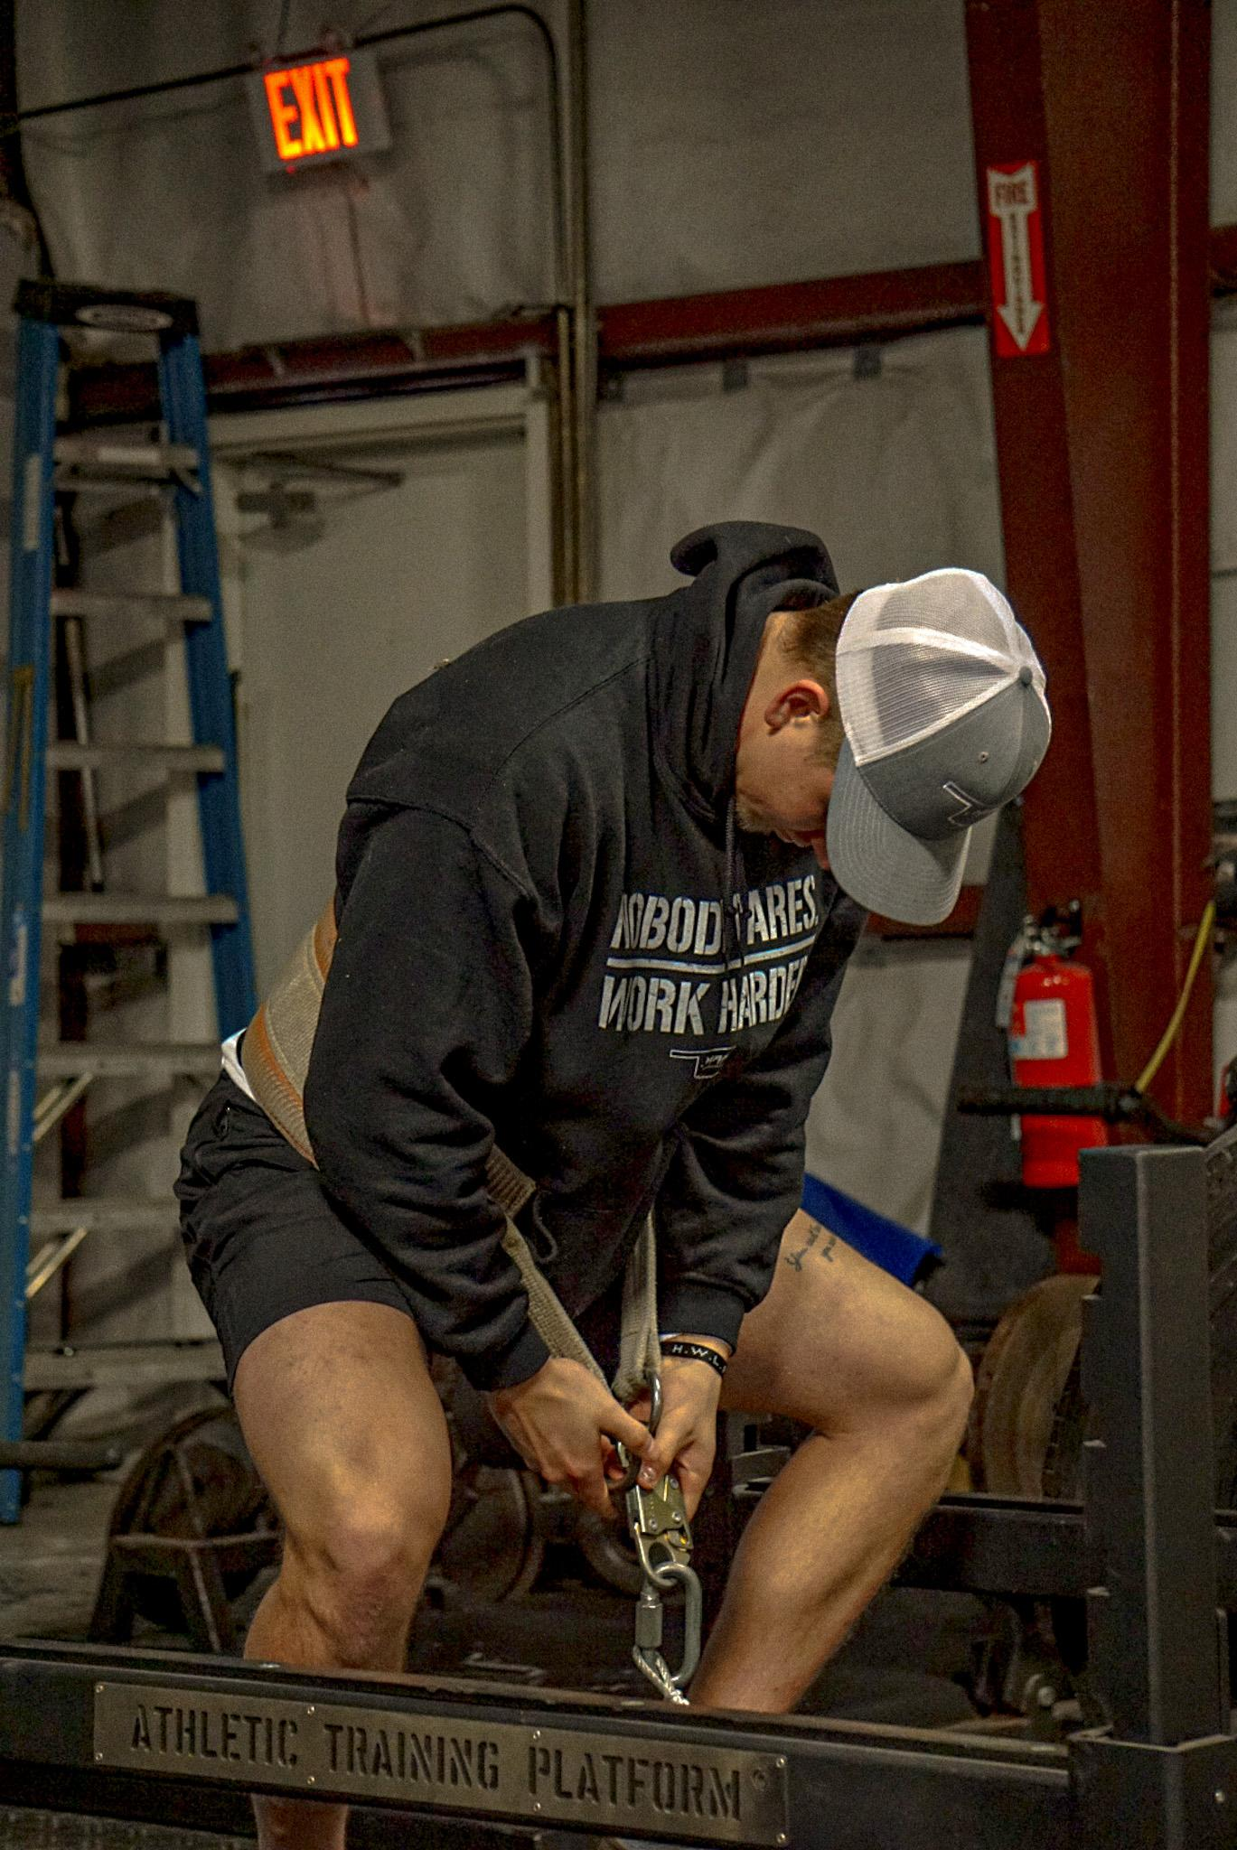

The application process is simple. It makes sure people who aren’t willing to put in any effort don’t reach out to me in the first place. You are who you associate with. Show me your 5 best friends, and I’ll show you where you’ll be in 5 years.

Name:
Phone Number:
Social Media:

What plan are you interested in? The ALL IN coaching plan, one of the specific online programs and nutrition services, or one of the specific online programs I help run through MAP?

What is your goal and why?

How long have you been working towards your current goal or even better, is this a new goal?

By accomplishing this goal, what do you gain?

What is your past history with training? Is this new to you?

Walk me through a typical day: What do you eat, where do you go, how active are you in your daily life?

What is your past history with following a diet plan? Is that something that has been easy or hard for you in the past?

Simply copy and paste this into an email, send back to maperformance18@gmail.com, and I will get back to you within 24 hours. -Austin Maine

Most will not even go this far as this process takes too much effort for them. That alone should show you just how special you already are.

